The Annual Complaints Performance and Service Improvement Report

The Annual Complaints Performance and Service Improvement Report was reviewed by the Trustees on 12.05.2026.
Chair Statement:
“As Chair of the Board of Trustees I am the Member Responsible for Complaints. (MRC). I have reviewed the Annual Report and am satisfied that the report accurately reflects our service during the previous 12 months”.

Signed By:

Josephine Marsden (person responsible for complaints)
Date: 12.05.2026
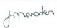
___________________________________________________

Joe Wilkinson Sherburn House Charity Trustee (Chair)

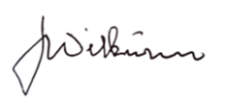
_____________________________________________________
Date: 12.05.2026

Pauline Bishop (CEO)
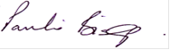
___________________________________________________
Date:12.05.26

